SENNHEISER and Neumann present a host of audio solutions at met 2019
Sydney, 15 July 2019 – Sennheiser and Neumann are at the Media and Entertainment Expo, from 17th-19th July 2019 at ICC Sydney, Darling Harbour, presenting a wide range of audio solutions, including audio for video products, wireless microphone systems from entry-level to high-end professional, and studio monitoring solutions. Product highlights include the new SK 6212 digital mini-bodypack, and the new XSW-D series entry level kits for both live performance and camera applications, plus new products from Neumann, the NDH 20 studio monitoring headphones and the KH 750 DSP subwoofer. Another major highlight on the stand is Sennheiser’s immersive AMBEO 3D technology solutions, with a prototype of an AMBEO Sports Microphone Array for capturing 360° sound on display.

“We see broadcast and content production as a dynamic industry engaging a diverse range of customers with different requirements; these range from enhancing audio for mobile phone recording through to multi-channel audio solutions for professional applications and productions”, says Adam Karolewski Product Manager, Pro Audio Solutions for Sennheiser Australia & New Zealand, “We are proud to be able to offer a comprehensive range of innovative and leading edge audio solutions to cater for all these needs.”

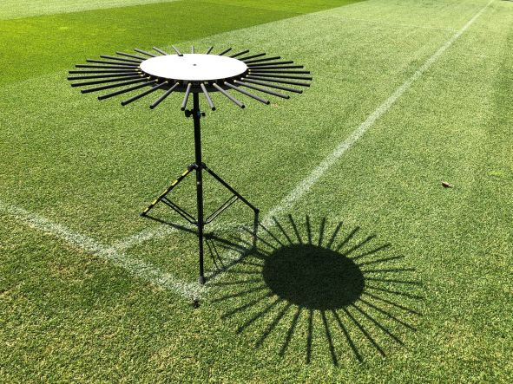 | The prototype AMBEO Sports Microphone Array for 360° sound will be on display.

Sennheiser’s AMBEO Technology
In support of the AMBEO Sports Microphone Array, special guest Renato Pellegrini, AMBEO product manager for Sennheiser globally, will also be at the show and delivering a session on ‘Object-Audio Capture Systems for Sports Broadcasting’. You will see him in Room B on Wednesday July 17th at 2:30pm. To complete the AMBEO set up Sennheiser will also be showcasing the AMBEO VR Microphone and the Neuman KU 100 binaural head.
Neumann
The NDH 20 is the first headphone produced by Neumann, it combines a newly developed Neumann transducer with a comfortable, closed-back design that includes soft memory foam ear pads. Featuring a balanced, linear sound image, fine resolution and excellent isolation, the headphone is ideal for monitoring, editing and mixing even in loud environments. The NDH 20 is foldable for easy transport, and is delivered with two detachable cables, one coiled, one straight.

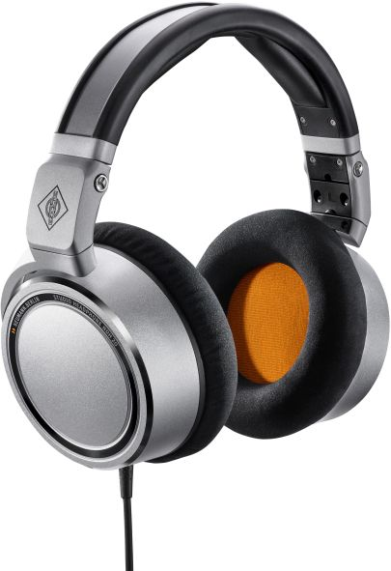 | The Neumann NDH 20 is a closed-back studio monitoring headphone with a flat frequency response and natural, detailed sound

Also, on the stand from Neumann, will be the KH 80 DSP nearfield monitor and the new KH 750 DSP subwoofer. Both models are an ideal choice for the confined spaces of broadcast studios. A DSP engine optimises their output, enabling critical monitoring with reference class sound despite their compact size. In addition, both the KH 80 DSP nearfield monitor and the KH 750 DSP subwoofer can be controlled with the Neumann.Control app for iPad.

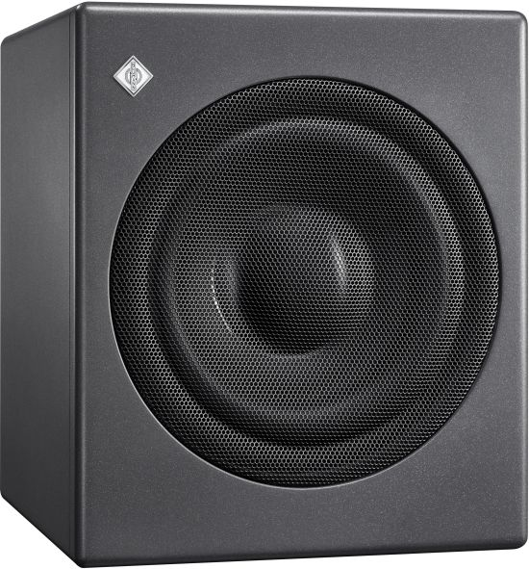  The new KH 750 DSP is a particularly compact subwoofer for broadcast, music and post production studios | 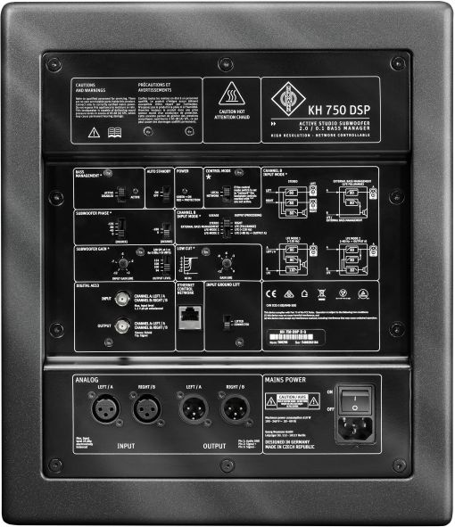
Professional Wireless Audio
Visitors will also find an area dedicated to Sennheiser’s high-end professional wireless products with the award winning Digital 6000 range, including the digital/analog camera receiver, the EK 6042, and also the new SK 6212 mini-bodypack transmitter, designed for multi-channel audio applications in the fields of broadcasting, musical theatre and live audio. Also on display is the 3000/5000 series microphones and a selection from the evolution wireless G4 100, 300 and 500 series.

The tiny SK 6212 mini-transmitter will make its first appearance at a tradeshow in Australia | 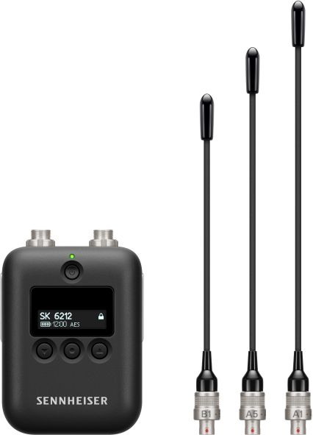

Entry-Level Wireless Audio
Sennheiser’s XS Wireless Digital series provides musicians and videographers with an easy entry into wireless audio. XSW-D replaces the cable with sleek, compact transmitters and receivers that work on 2.4 GHz for worldwide, license-free operation. Versatile and easy to use, the series provides wireless solutions for almost every conceivable configuration and application. Transmitters and receivers can be freely combined, so users can opt for a wireless link that will protect their existing microphone investments, or they can select one of the fully-equipped wireless microphone sets.
Sennheiser’s XSW-D series is an ideal entry into wireless audio for video or live performance | 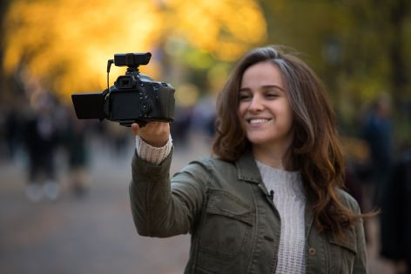

Audio for Video
For visitors looking for a solution for their camera audio capture, they will be delighted with a range of products on display including the new XSW-D products, the AVX wireless system and the wired MKE microphones, including the MKE 400 mini-shotgun, the larger MKE 600 and the MKE 440 stereo model. Content creators who prefer to work with their smartphones, will also find the Memory Mic. This clip-on model works wirelessly with any smartphone, at any distance, via a companion app.

Visit Sennheiser and Neumann on stand A32

About Sennheiser and Neumann
Shaping the future of audio and creating unique sound experiences for customers – this aim unites Sennheiser employees and partners worldwide. Founded in 1945, Sennheiser is one of the world’s leading manufacturers of headphones, microphones and wireless transmission systems. Since 2013, Sennheiser has been managed by Daniel Sennheiser and Dr. Andreas Sennheiser, the third generation of the family to run the company. As part of the Sennheiser Group, Georg Neumann GmbH, known as “Neumann.Berlin”, is the world’s leading manufacturer of studio microphones. Founded in 1928, the company has been recognised with numerous international awards for its technological innovations. Since 2010, Neumann.Berlin have expanded their expertise in electro-acoustic transducer design to also include the studio monitor market and have recently added studio monitoring headphones to their portfolio. In 2018, the Sennheiser Group generated turnover totaling €710.7 million.
www.sennheiser.com | www.neumann.com

Press Contacts

Sennheiser Australia & New Zealand Hausmann
Heather Reid Lauren Benson
heather.reid@sennheiser.com lauren.benson@hausmann.com.au
+61 448 119 609 + 61 404 242 262

